Game Design Document

Fill up the Following document

1. Write the title of your project.

Subway surf.

1. What is the goal of the game?

To collect the coins.

1. Write a brief story of your game?

It is an infinite game. the boy has to collect the coins.

He has to save himself from trains and the police. If he hit

The train the police will caught him.

1. Which are the playing characters of this game?

* Playing characters are the ones which respond to the user based on the input from the user
* Cars, monkeys, dinos, wizards etc, are the playing characters in the game.

|  |  |  |
| --- | --- | --- |
| Number | Character Name | What can this character do? |
| 1 | boy | He has to collect the coins |
| 2 | Police and dog | If the boy hits the train or the obstacle he will catch him |
| 3 |  |  |
| 4 |  |  |
| 5 |  |  |
| 6 |  |  |
| 7 |  |  |
| 8 |  |  |

1. Which are the Non Playing Characters of this game?

* Non Playing characters are the ones which don't have an action or a behaviour when the user interacts with the game.
* Hurdles, stones, bananas, coins, etc are non playing characters in the game.

|  |  |  |
| --- | --- | --- |
| Number | Character Name | What can this character do? |
| 1 | train | It is an obstacle. that stops the boy to move. |
| 2 | Coin | This is the coin that the boy had to collect. |
| 3 |  |  |
| 4 |  |  |
| 5 |  |  |
| 6 |  |  |
| 7 |  |  |
| 8 |  |  |

Draw your imagination of this game. What does this game look like?

* Draw the game either on your computer or on paper,
* Add images of scenes of the game to show each of the playing and non-playing characters at least once.

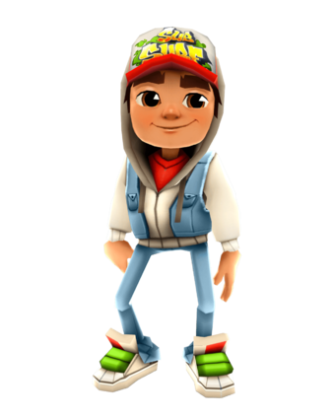

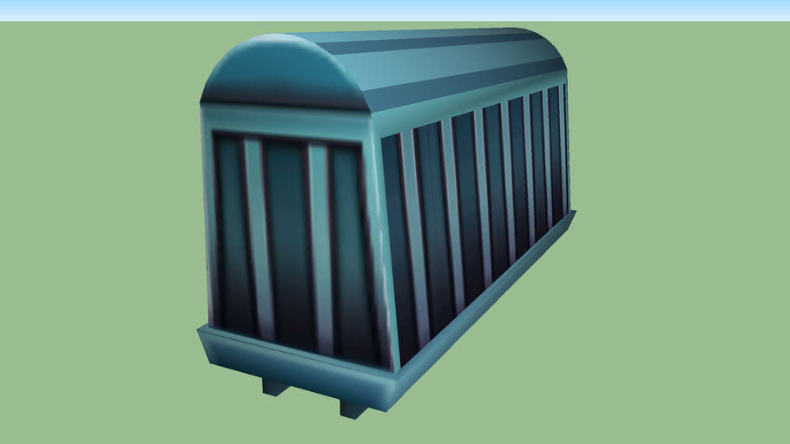



How do you plan to make your game engaging?

I had played this game then I think it is a nice game then I

designed to Make this game